**CONTROL STRUCTURES.**

**Scenario 1**: The bank wants to apply a discount to loan interest rates for customers above 60 years old.

* + Question: Write a PL/SQL block that loops through all customers, checks their age, and if they are above 60, apply a 1% discount to their current loan interest rates.

**SOLUTION:**

**Query:** select * from loans;

**Output:**

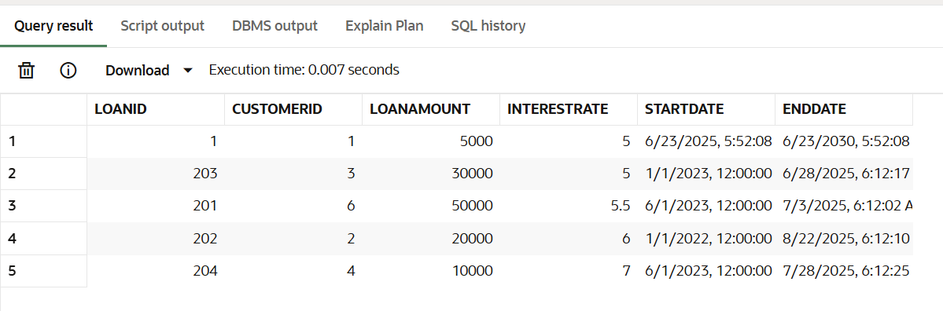

**Query:**

begin

    update loans l set l.interestrate=l.interestrate*0.99 where l.customerid in (select

    c.customerid from customers c where months_between(sysdate,c.dob)/12>60);

    dbms_output.put_line('DISCOUNT APPLIED');

end;

**Output:**

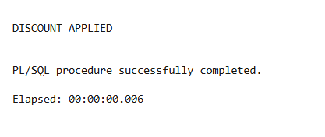

**Query:** select * from loans;

**Output:**

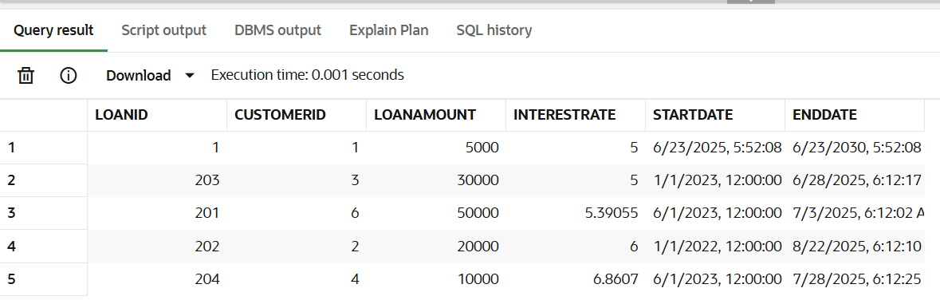

**Scenario 2:** A customer can be promoted to VIP status based on their balance.

* + Question: Write a PL/SQL block that iterates through all customers and sets a flag IsVIP to TRUE for those with a balance over $10,000.

**SOLUTION:**

**Query:** alter table customers add Isvip Boolean;

**Output:**

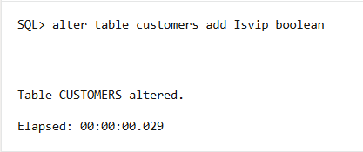

**Query:** select * from customers;

**Output:**

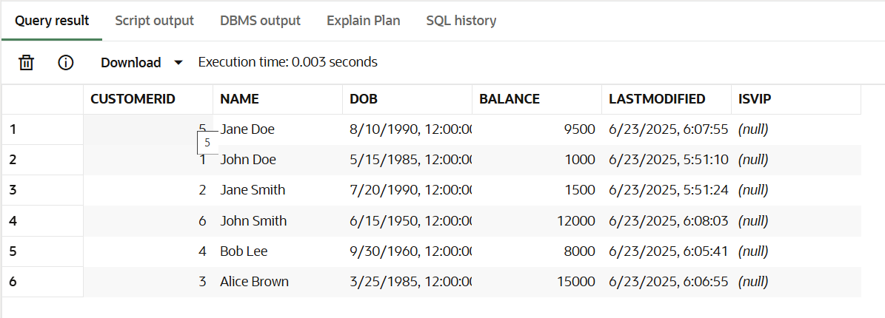

**Query:**

begin

    update customers set isvip=case when balance>=10000 then 'true' else 'false'

    end;

    dbms_output.put_line('Isvip set');

end;

**Output:**

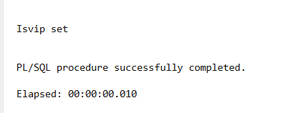

**Query:** select * from customers;

**Output:**

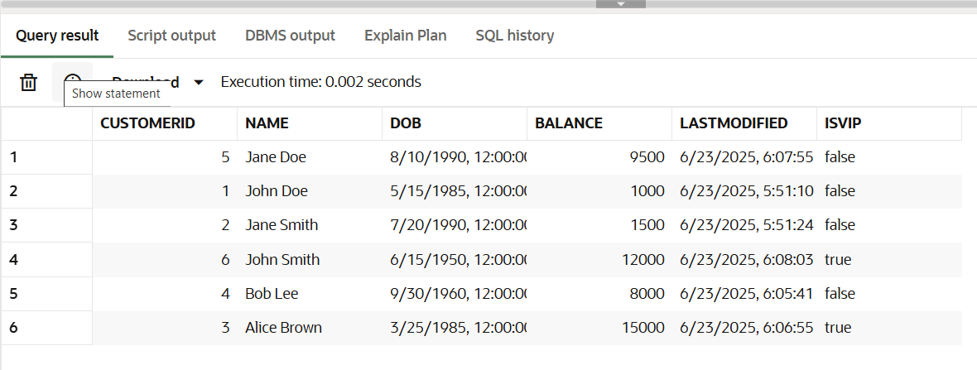

**Scenario 3:** The bank wants to send reminders to customers whose loans are due within the next 30 days.

* + **Question:** Write a PL/SQL block that fetches all loans due in the next 30 days and prints a reminder message for each customer.

**SOLUTION:**

**Query:**

begin

    for rec in(

        select c.name, c.customerid ,l.loanid ,l.enddate from loans l join customers c on c.customerid=l.customerid where enddate between sysdate and sysdate+30

    )loop

        dbms_output.put_line('CUSTOMER :'||rec.name||chr(10)||' with CUSTOMERID: '||rec.customerid||chr(10)||' and LOANID:'||rec.loanid||chr(10)||' has a loan due on '||rec.enddate);

    end loop;

end;

**Output:**

